**DBMS PROJECT REVIEW II**

**BLOOD BANK MANAGEMENT SYSTEM**



|  |  |
| --- | --- |
| **GROUP MEMBERS** | **ROLL NO** |
| SREESANKAR S | AM.EN.U4CSE20366 |
| DEVESH KUMAR V V | AM.EN.U4CSE20321 |
| VIGNESH A NAIR | AM.EN.U4CSE20374 |

**COMPUTER SCIENCE DEPARTMENT**

**AMRITA VISHWA VIDYAPEETHAM**

**DECEMBER 2021**

**ABSTRACT**

This Project ‘Blood Bank Management System’ is an automated digital system that stores and retrieves the information related to blood donation. The project aims to provide an efficient and convenient way to manage Blood Bank System.

This system allows the donor or receiver to enter the system and choose his or her purpose and store the details corresponding to their need. After that he or she gets a confirmation message regarding their purpose and their slot booking details.

This system also allows the donor or receiver to register to the system and give the information such as blood group, dob, appointment, etc.

Blood Bank Management System allows the donor to store the details regarding their donation. After that the receiver who needs the blood will check the availability of blood with the help of the system. After the availability is checked, corresponding message is shown and the status in stored in the database regarding the receiving of the blood.

The relations in our project are

* Register
* Donation_details
* Receiving_details
* Donation_Status
* Receiving_Status

**RELATION DESCRIPTION**

* **Register**

Our Register contains First Name, Last Name, Mobile Number, User ID, DOB, Gender, Weight, Blood Group, Password, Address, Disability.

* **Donation_details**

Our Donation_details contains User ID, Donation ID, Donor Blood Group, Donating Branch, Amount of Blood Donating, Donating Date, Donating Time slot.

* **Receiving_details**

Our Receiving_details contains User ID, Receiver ID, Receiver Blood Group, Receiving Branch, Amount of Blood Receiving, Receiving Date, Receiving Time slot.

* **Donation_Status**

Our Donation_Status contains User ID, Donation status ID, Donation status like confirmed or not.

* **Receiving_Status**

Our Receiving _Status contains User ID, Receiving status ID, Receiving status like confirmed or not.

**ER DIAGRAM**

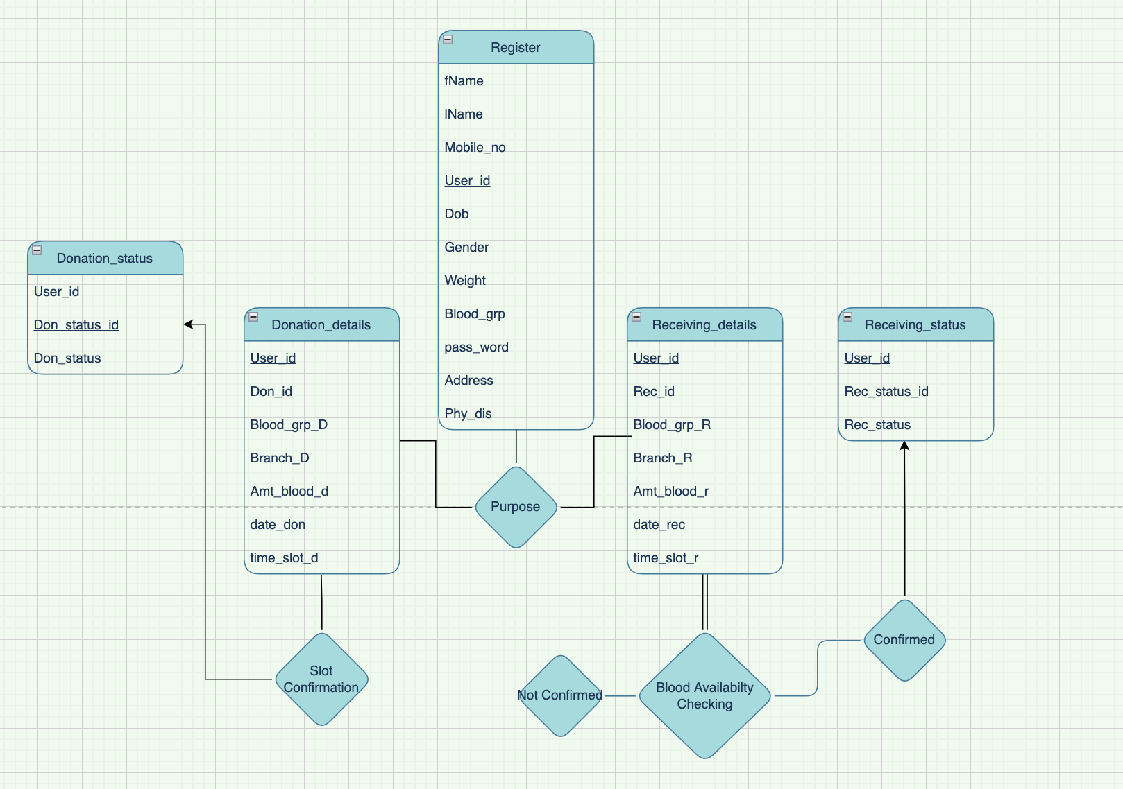

**SCHEMA DIAGRAM**

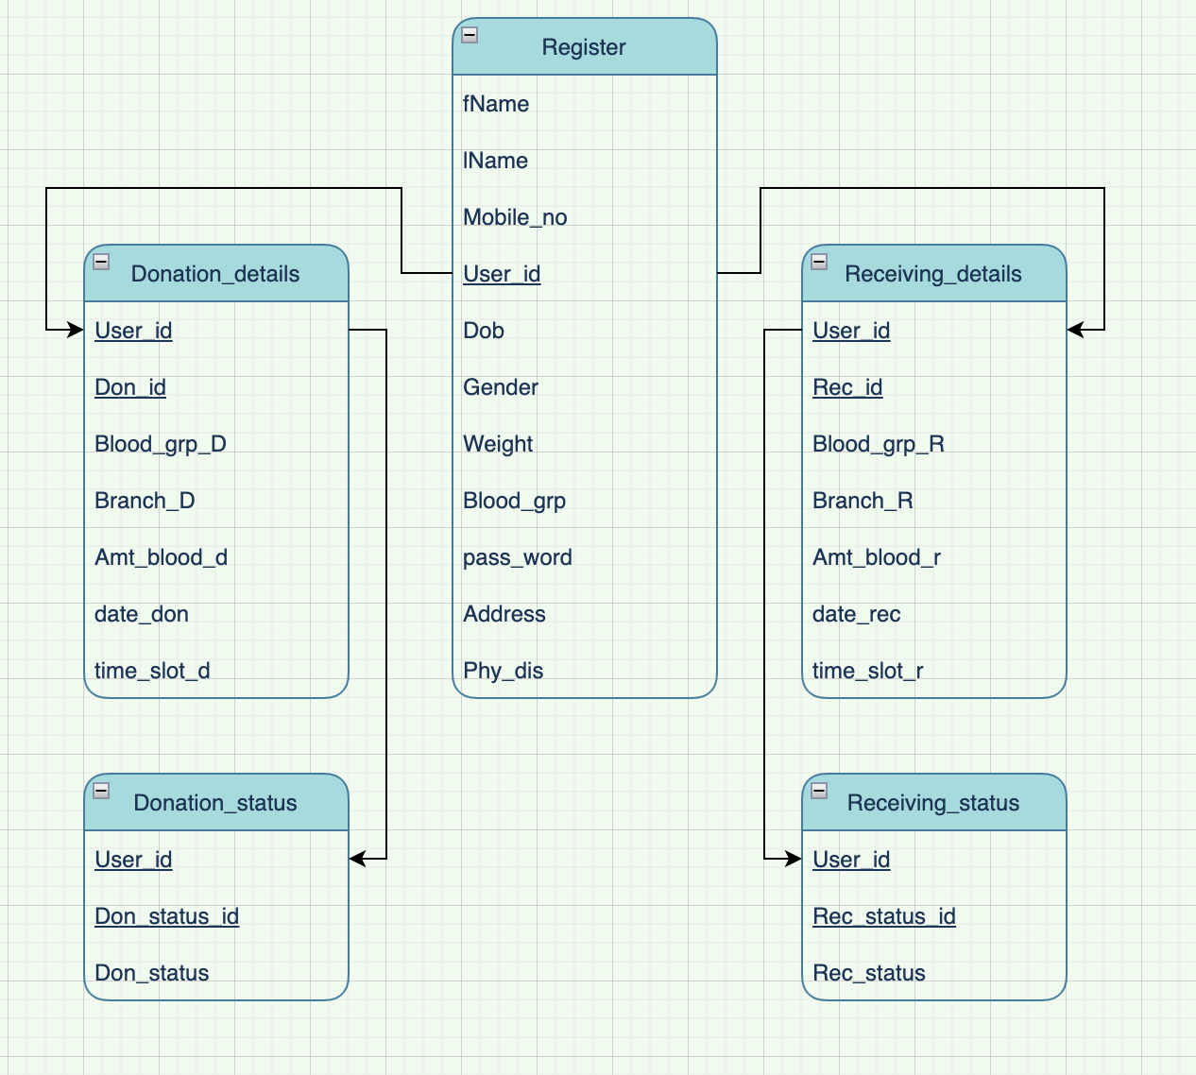

**ADDITIONAL INFORMATION**

* User_id - The ID assigned to a user while registering. One User will only have one User ID.
* Don_id - The ID assigned to a user while Donating. One Donor will only have one Donor ID.
* Rec_id - The ID assigned to a user while Receiving. One Donor will only have one Receiver ID.
* Don_Status_id- The ID given after confirmation of Donation.
* Rec_Status_id- The ID given after confirmation of Receiving.

|  |  |
| --- | --- |
| **Relation** | **Primary Key** |
| Register | User_id |
| Donation_details | Don_id |
| Receiving_details | Rec_id |
| Donation_Status | Don_Status_id |
| Receiving_Status | Rec_Status_id |

**NORMALIZATION**

**UNIVERSAL TABLE**



**1NF**

* A relation will be 1NF if it contains an atomic value.
* It states that an attribute of a table cannot hold multiple values. It must hold only single-valued attribute.
* First normal form disallows the multi-valued attribute, composite attribute, and their combinations.

Our relation does not have multi-valued attributes and all the attributes are single valued attributes. This relation does not contain any composite attributes.

Our Universal table follows the rules of 1NF



**2NF**

* In the 2NF, relational must be in 1NF.
* In the second normal form, all non-key attributes are fully functional dependent on the primary key

We don’t have any partial dependency and all non-key attributes are fully functional dependent on the primary key.

Following the rules of 2NF

**Register**

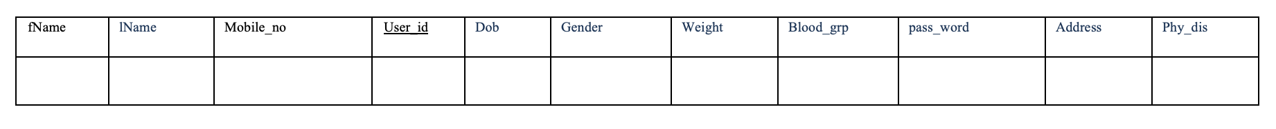

**Donation_details**

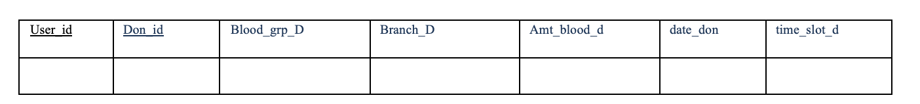

**Receiving_details**

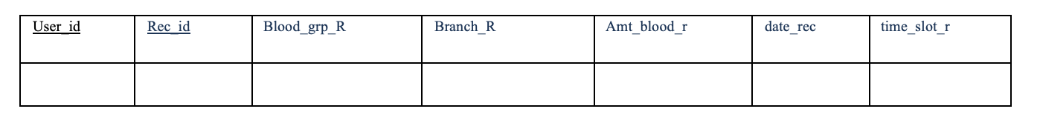

**Donation_Status**

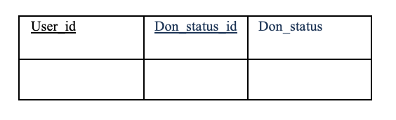

**Receiving _Status**

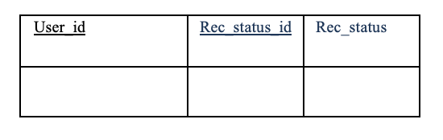

**3NF**

* A relation will be in 3NF if it is in 2NF and not contain any transitive partial dependency.
* 3NF is used to reduce the data duplication. It is also used to achieve the data integrity.
* If there is no transitive dependency for non-prime attributes, then the relation must be in third normal form.

Since we don’t have any transitive dependency for non-prime attributes our relation is in 3NF

Following the rules of 3NF

**Register**



**Donation_details**



**Receiving_details**



**Donation_Status**



**Receiving _Status**



**DDL STATEMENTS**

**Register**

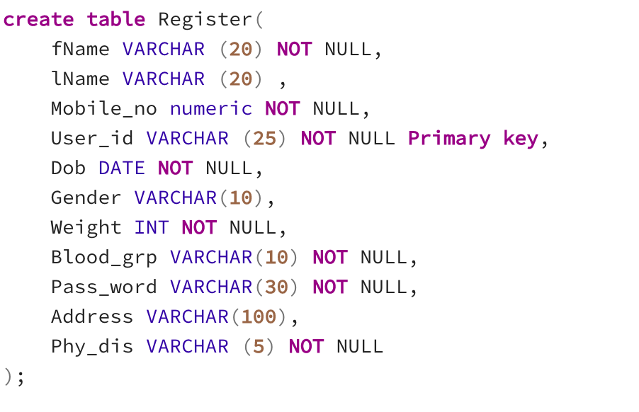

**Donation_details**

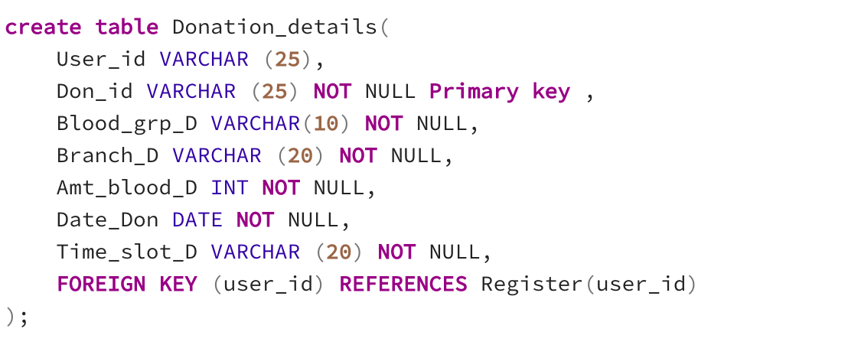

**Receiving_details**

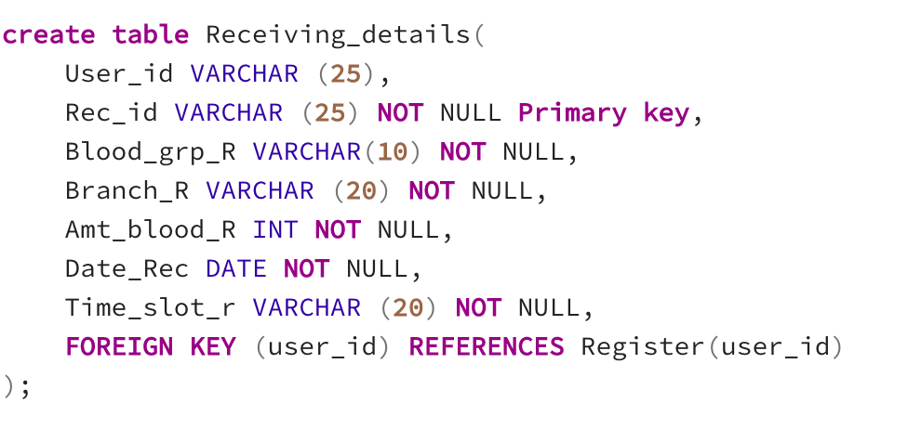

**Donation_Status**

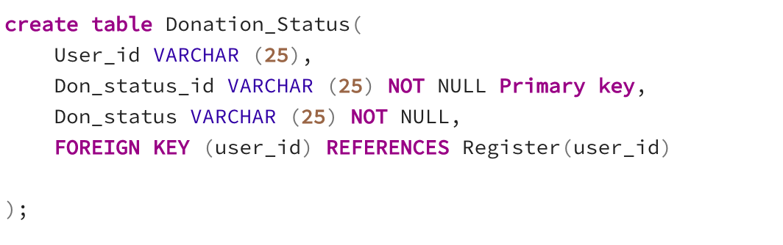

**Receiving _Status**

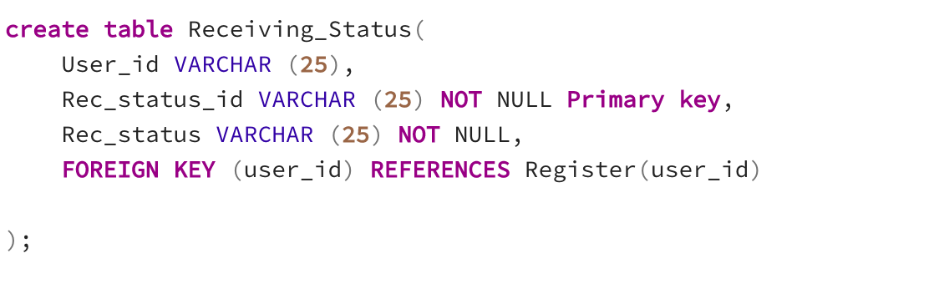

**INSERTION QUERIES**

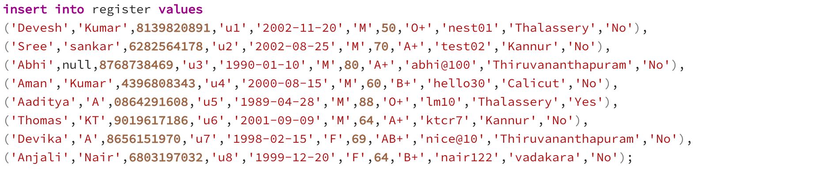



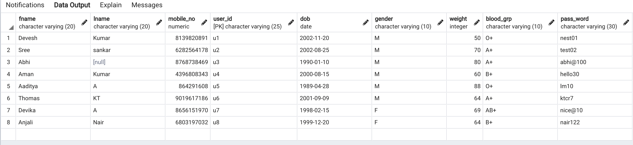

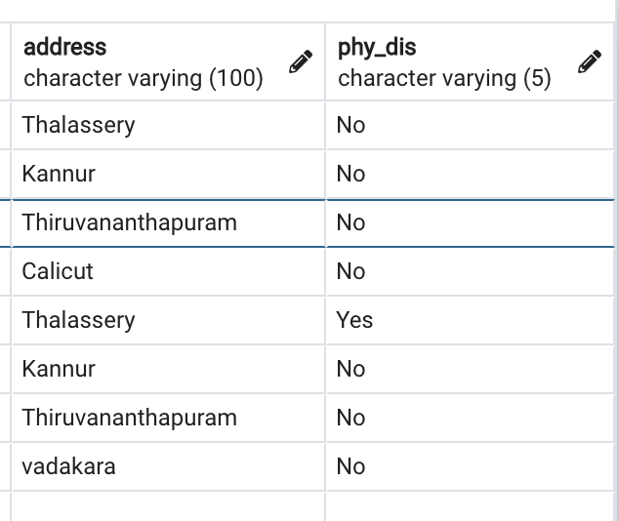

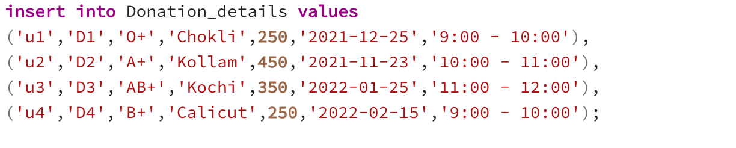



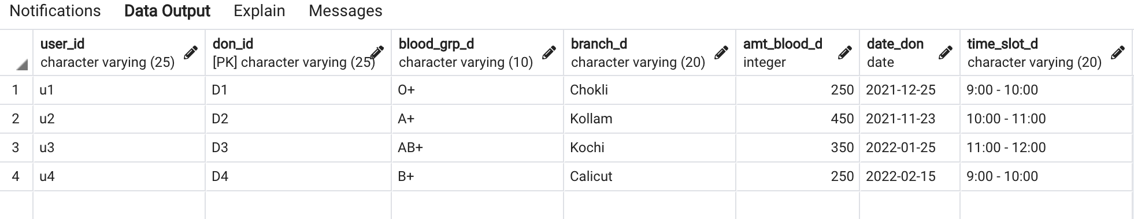

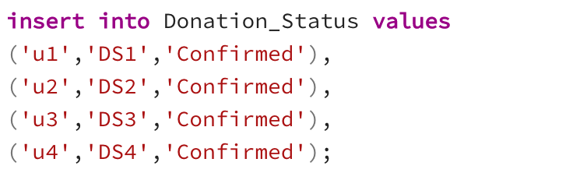



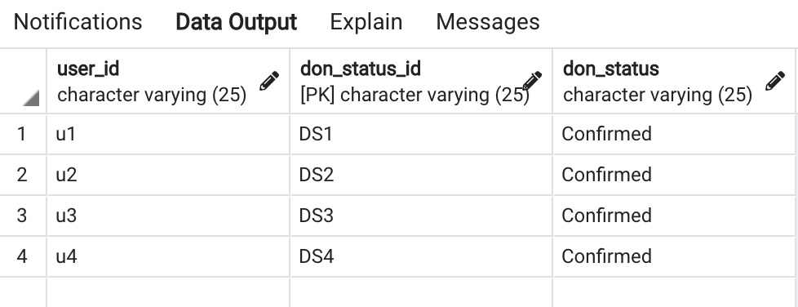

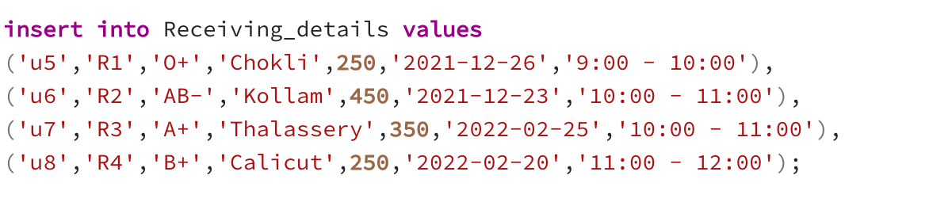



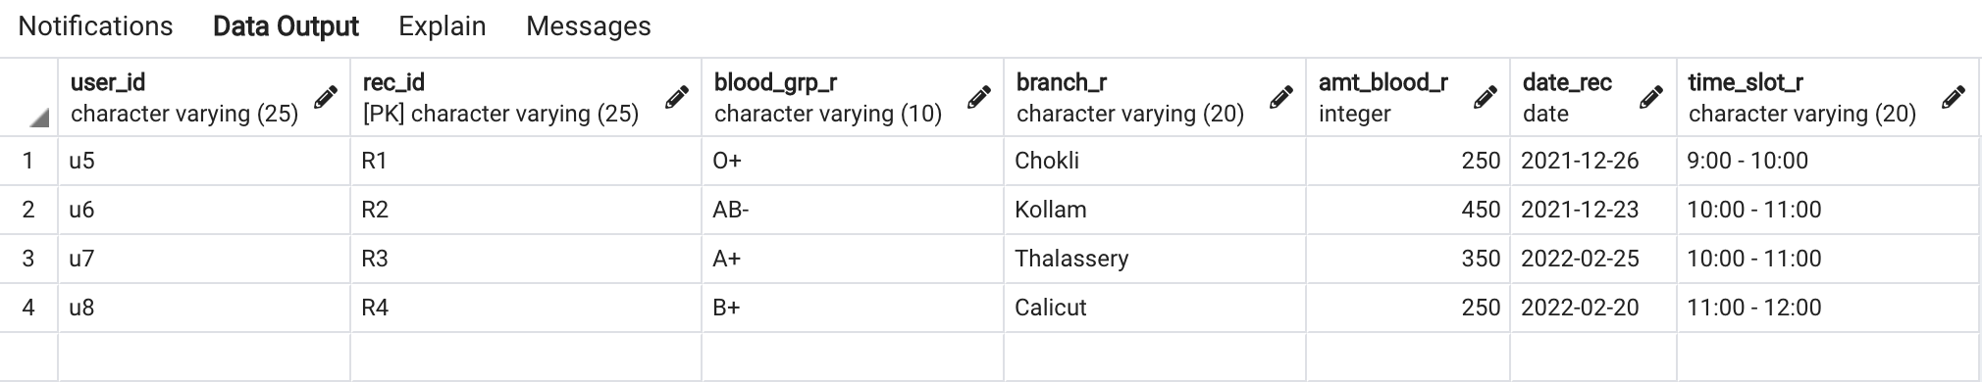

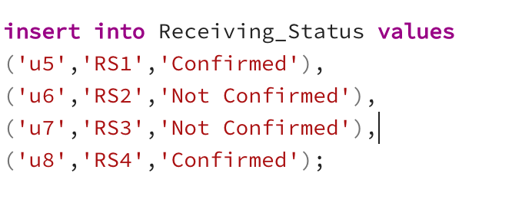



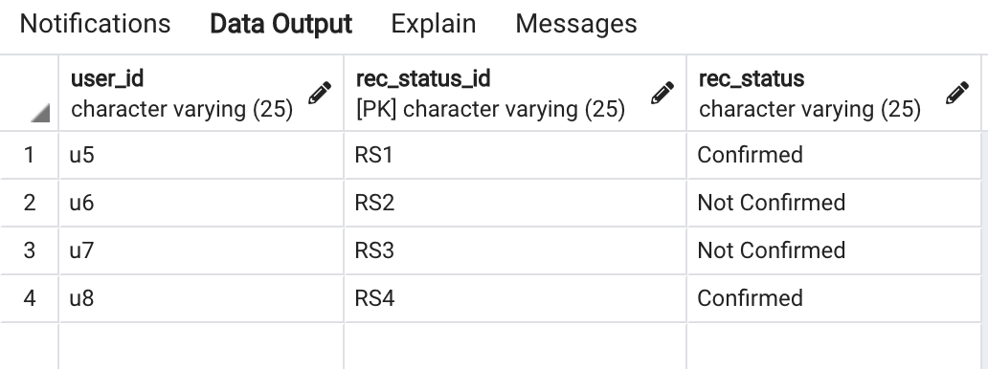

**QUERIES AND ITS RESULTS**

1. **Aggregate functions, Group by...having**

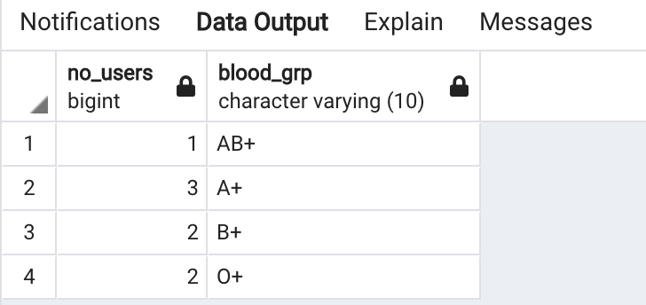

1. **Order by**

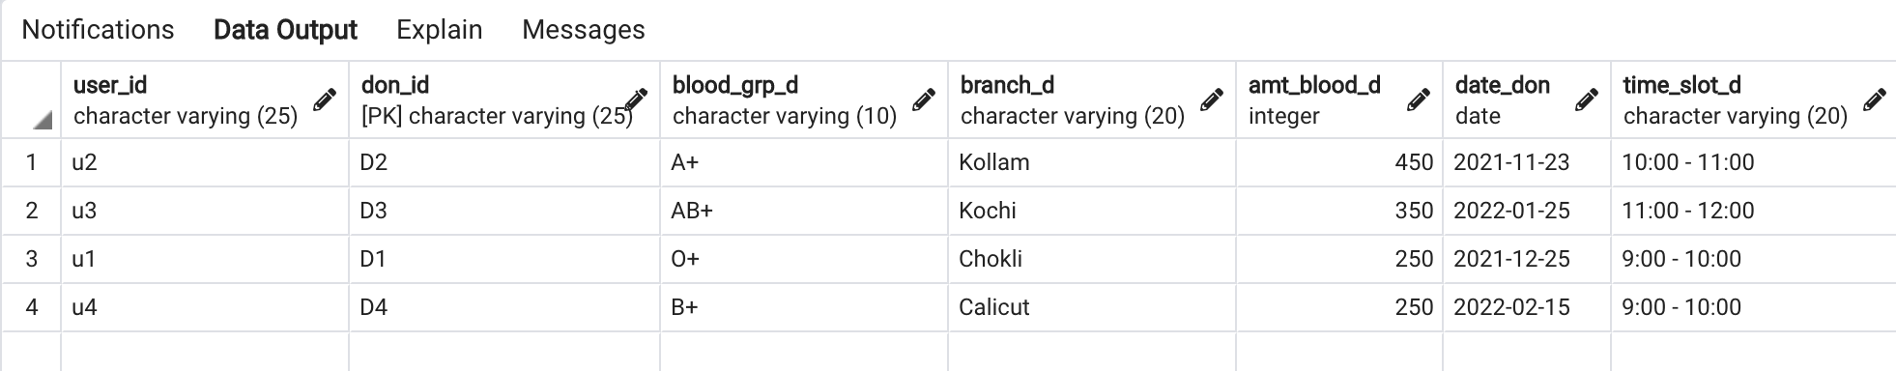

1. **Join, Outer Join**

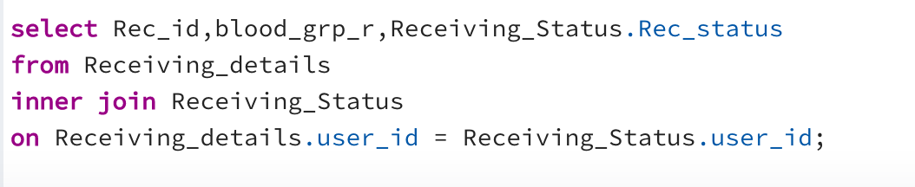

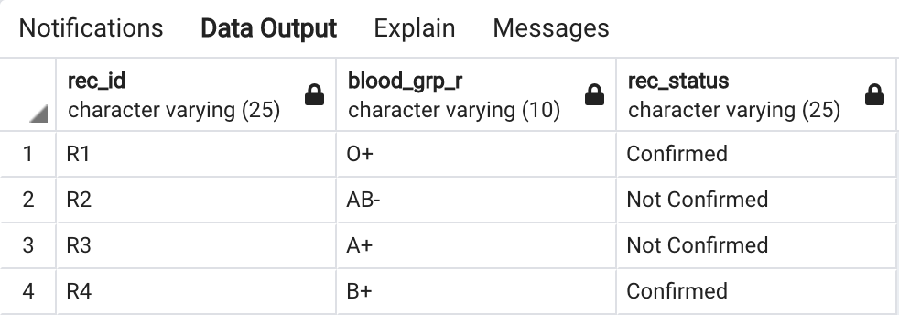

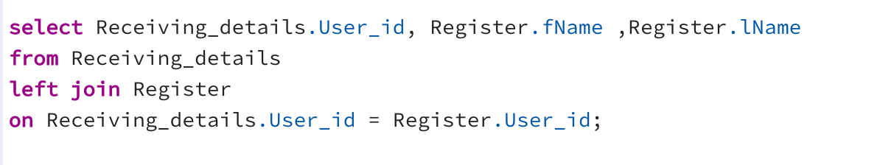

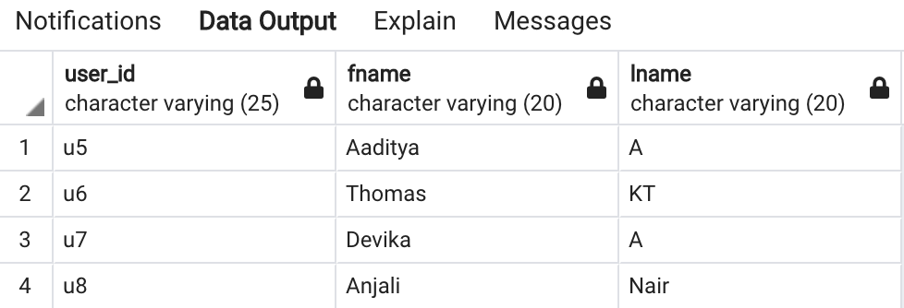

1. **Query having Boolean operators**

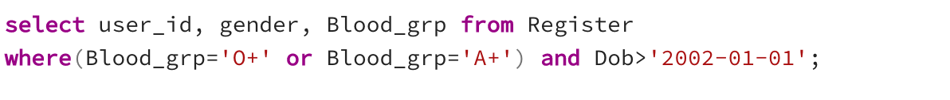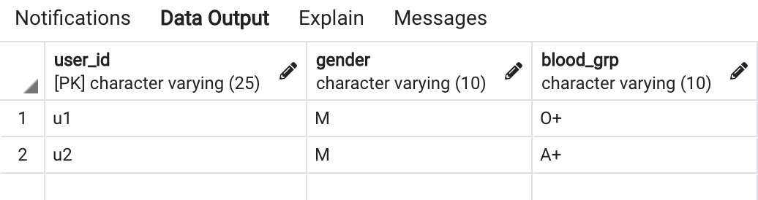

1. **Query having arithmetic operators**

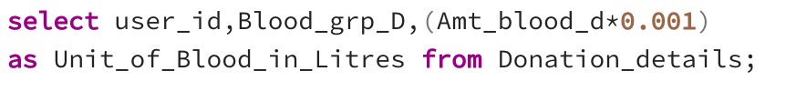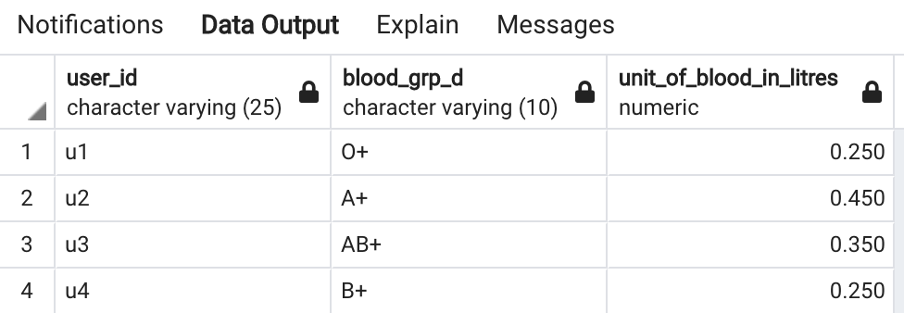

1. **A search query using string operators**

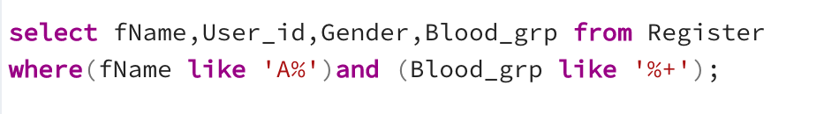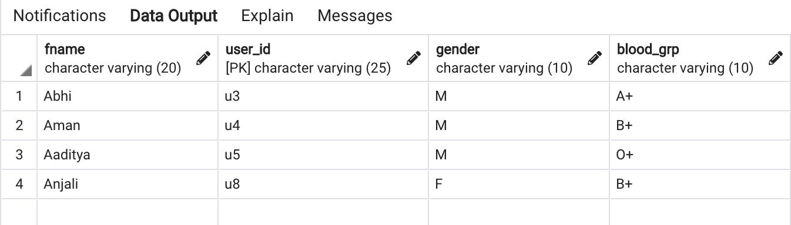

1. **Usage of to_char, extract**

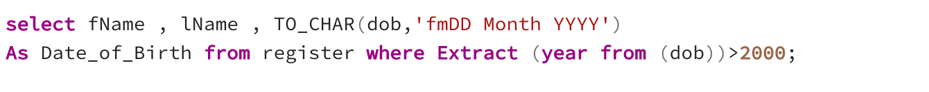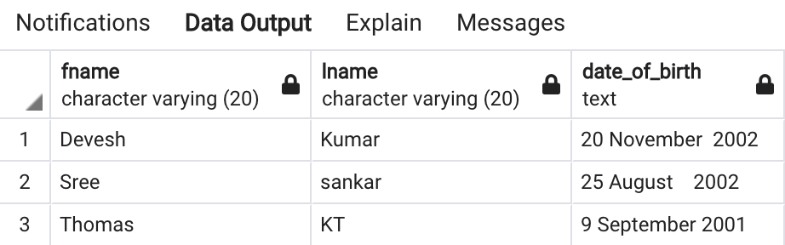

1. **Between, IN, Not between, Not IN**

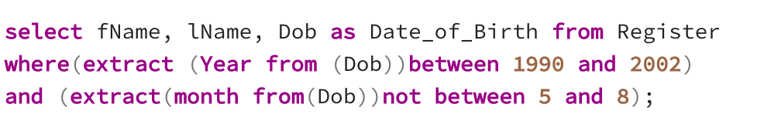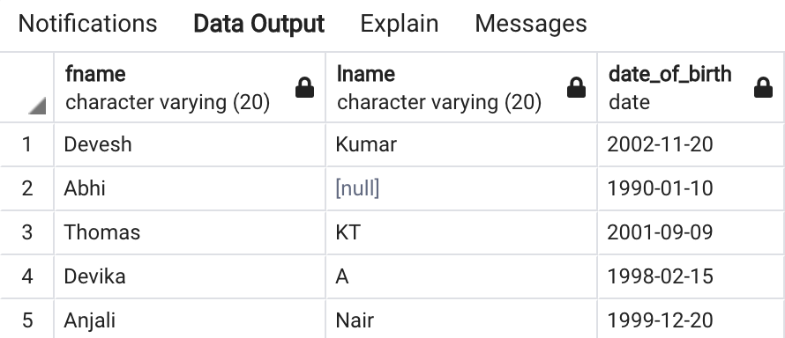

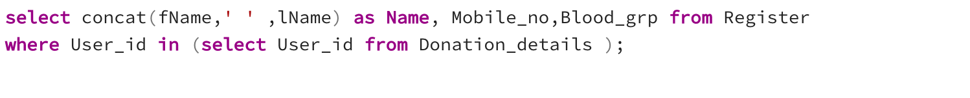

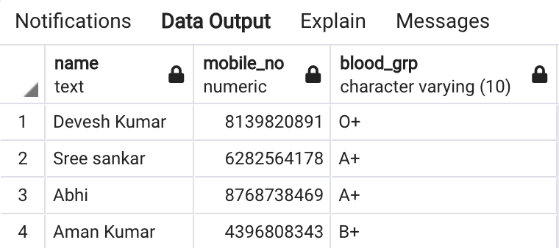

1. **Set operations**

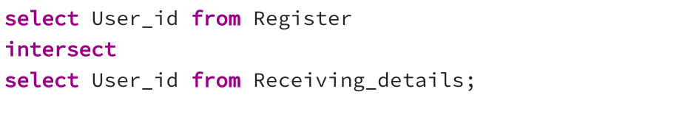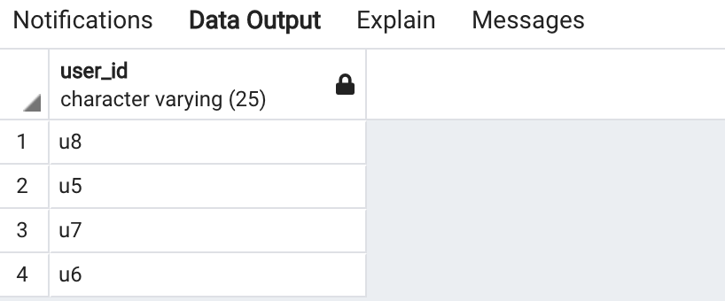

1. **Subquery using EXISTS / NOT EXISTS, ANY, ALL**





